1. What is Ansible?
Ansible is an open-source automation and configuration-management tool.
It is mainly used to automate tasks on multiple servers, such as:
- Installing software
- Starting/stopping services
- Creating users
- Copying files
- Changing configurations
- Deploying applications
- Managing AWS infrastructure
- Performing the same task on 10, 100, or 1000 servers

Simple example
Suppose you have 10 AWS EC2 Linux servers.
Without Ansible:
Server 1 → SSH → install Apache
Server 2 → SSH → install Apache
Server 3 → SSH → install Apache
...
Server 10 → SSH → install Apache
With Ansible:
Ansible
|
-----------------------
| | | | |
EC2 EC2 EC2 EC2 EC2
1 2 3 4 5
You give one command/playbook and Ansible performs the task on all required servers.

2. Who created Ansible?
Ansible was created by Michael DeHaan.
- Creator: Michael DeHaan
- Initially released: 2012
- Company behind Ansible: Ansible, Inc.
- Acquired by: Red Hat in 2015
- Today Ansible is part of the Red Hat ecosystem.
The name Ansible was inspired by a fictional communication device that could communicate across very large distances almost instantly.

3. Why was Ansible created?
The main problem was:
How can we manage many servers automatically instead of manually logging into every server?
Before configuration-management/automation tools, administrators often had to SSH into servers individually.
For example, imagine an AWS environment:
100 EC2 instances
↓
Need to install nginx
↓
Without automation:
SSH → EC2-1
SSH → EC2-2
SSH → EC2-3
...
SSH → EC2-100
This is:
- Slow
- Error-prone
- Difficult to maintain
- Not scalable
Ansible solves this by allowing:
Ansible
↓
100 EC2 instances
↓
Install nginx automatically

4. What is Control Node?
The Control Node is the machine from which you run Ansible.
It contains Ansible and is responsible for sending instructions to managed machines.
For example:
CONTROL NODE
Ansible installed
|
--------------|--------------
| | |
↓ ↓ ↓
EC2-1 EC2-2 EC2-3
Managed Managed Managed
Node Node Node
The Control Node could be:
- Your laptop
- A Linux server
- An AWS EC2 instance
- A management server
- A CI/CD server

Example
You have:
Amazon Linux EC2
Private IP: 10.0.1.10
You install Ansible on it:
sudo dnf install ansible-core -y
That EC2 becomes your Control Node.

5. What are Managed Nodes / Managed Clients?
The machines that Ansible manages are called:
Managed Nodes
or sometimes:
Managed Clients
For example:
Control Node
Ansible Server
|
---------------------
| | |
↓ ↓ ↓
EC2-1 EC2-2 EC2-3
Managed Managed Managed
Node Node Node
The managed nodes are generally not required to have Ansible installed.
This is one of the important features of Ansible.

6. How does Ansible communicate?
For Linux/Unix managed nodes, Ansible normally uses:
SSH
Example:
Control Node
|
| SSH
↓
Amazon Linux EC2

Install Ansible Control Node on CentOS 9

Step 1 — Check your CentOS version
cat /etc/redhat-release
Expected:
CentOS Stream release 9
You can also check:
cat /etc/os-release

Step 2 — Check AppStream repository
Run:
sudo dnf repolist
You should see repositories including something similar to:
BaseOS
AppStream
Then specifically search for Ansible:
sudo dnf list ansible-core --available
Or:
sudo dnf info ansible-core

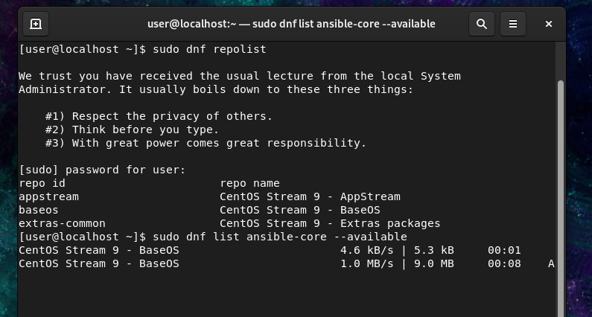
You should get information about the available ansible-core package.

Important concept
CentOS Stream 9
|
└── AppStream
|
└── ansible-core
So you do not need to download an Ansible RPM manually for this basic installation.

Step 3 — Install Ansible Core
Run:
sudo dnf install ansible-core -y
This is the normal method for CentOS Stream 9.
During installation, DNF will automatically install required dependencies.

Step 4 — Verify Ansible installation
Run:
ansible --version
You should see something similar to:
ansible [core 2.x.x]
python version = 3.x.x
jinja version = ...
libyaml = True

